## PIZZA SALES SQL QUERIES

1. **KPI**
2. **Total revenue**

select sum(total_price) as Total_Revenue from pizza_sales;



1. **Avg Order Value**

select sum(total_price) / count(distinct order_id) as Avg_Order_Value from pizza_sales;



1. **Total Pizza Sold**

select sum(quantity) as Total_Pizza_Sold from pizza_sales;



1. **Total Orders**

select count(distinct order_id) as Total_Orders from pizza_sales;

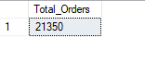

1. **Avg Pizza Per Order**

select cast(cast(sum(quantity) as decimal (10,2)) /

cast(count(distinct order_id) as decimal (10,2)) as decimal (10,2)) as Avg_Pizza_Per_Order from pizza_sales;

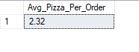

1. **Daily trends of order**

select datename(DW, order_date) as order_day, count(distinct order_id) as total_orders from pizza_sales group by datename(dw,order_date);

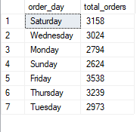

1. **Total order by month**

select datename(month, order_date) as month_name, count(distinct order_id) as total_orders from pizza_sales

group by datename(month, order_date)

order by total_orders desc;

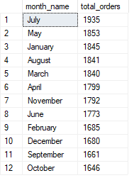

1. **Total pizza size sale by pct by qtr**

select pizza_size, cast(sum(total_price) as decimal (10,2)) as total_sales, cast (sum(total_price) * 100 / (select sum(total_price) from pizza_sales) as decimal (10,2)) as PCT

from pizza_sales

where datepart(quarter, order_date)=1/2/3/4

group by pizza_size

order by PCT DESC;

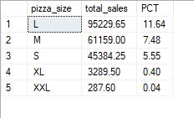

1. **Top 5 Pizza By Revenue by descending**

select top 5 pizza_name, sum(total_price) as total_revenue from pizza_sales

group by pizza_name

order by total_revenue desc

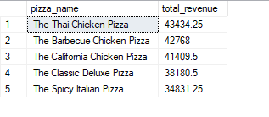

1. **Bottom 5 Pizza By Revenue by ascending**

select top 5 pizza_name, sum(total_price) as total_revenue from pizza_sales

group by pizza_name

order by total_revenue asc

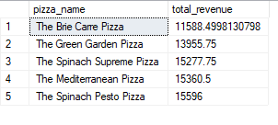

1. **Top 5 Pizza sold by quantity desc**

select top 5 pizza_name, sum(quantity) as Total_Quantity from pizza_sales

group by pizza_name

order by Total_Quantity desc

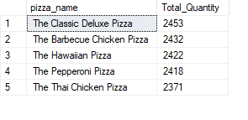

1. **Bottom 5 Pizza sold by quantity asc**

select top 5 pizza_name, sum(quantity) as Total_Quantity from pizza_sales

group by pizza_name

order by Total_Quantity asc

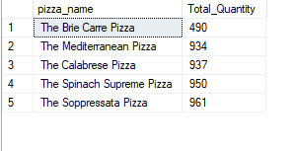

1. **Top 5 Pizza Name by total orders**

select top 5 pizza_name, count(distinct order_id) as Total_Orders from pizza_sales

group by pizza_name

order by Total_Orders desc

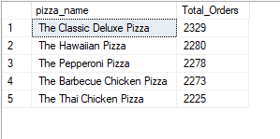

1. **Bottom 5 Pizza Name by total orders**

select top 5 pizza_name, count(distinct order_id) as Total_Orders from pizza_sales

group by pizza_name

order by Total_Orders

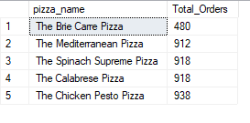

Started to make dashboard

1. 1st data cleaning by transforming the data in Power Bi
2. We change pizza size by using replace value (L to Large likewise)
3. Then close and apply
4. Report view
5. NEW MESURE
   * + - 1. For total revenue

* Total Revenue = SUM(pizza_sales[total_price]
  + - * 1. Total Orders
* Total Orders = DISTINCTCOUNT(pizza_sales[order_id]
  + - * 1. Avg Order Value
* Avg Order Value = [Total Revenue] / [Total Orders]
  + - * 1. Total Pizza Sols
* Total PIzza Sold = SUM(pizza_sales[quantity])
  + - * 1. Avg Pizza Sold per Order
* Avg Pizza Per Order = [Total PIzza Sold] / [Total Orders]

1. Let’s put our first dashboard
2. Put new card and put value or total revenue, Avg order value, Total Pizza Sold,

Total Order & Avg pizza per order.

1. Give title by using shape
2. Added column of day name by transforming data

Order Day = UPPER(LEFT(pizza_sales[Day Name], 3))

1. Took stacked column chart and put order day in x axis and total order in y axis

And give conditional formatting to column by using gradient as showed in below picture.

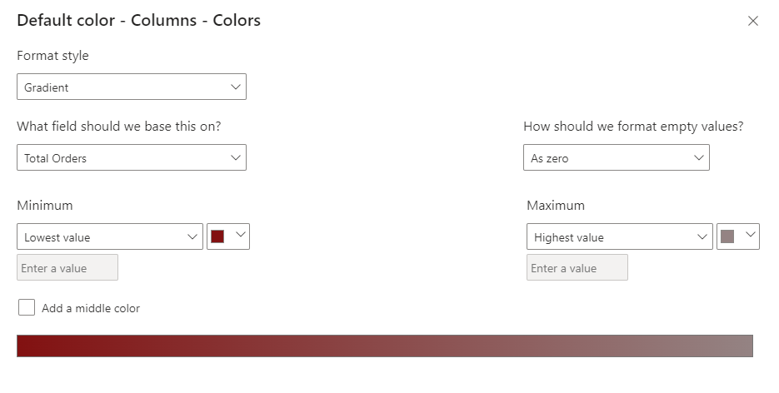

1. We have to line the stacked column day wise so we will have to add conditional column through power query.

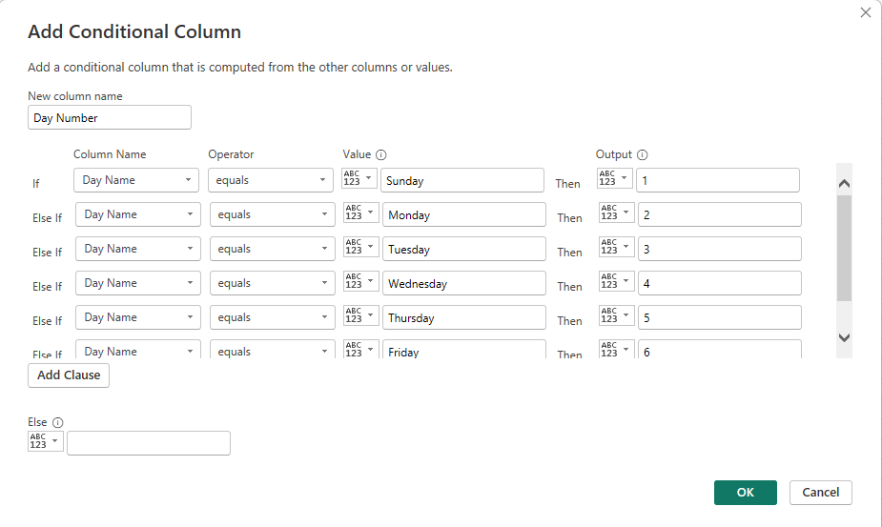

Then select order day from data and go on column tools sort by day number and in sort axis as showing in below picture

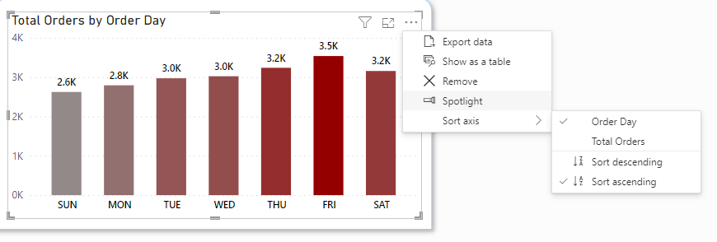

1. Copy and paste shape to prepare a new chart which will show month by creating power query again we will transform the data clicked in order date select date dropdown select month if will give you month name and again same form number or month.

And create new column in data by using

Order Month = UPPER(LEFT(pizza_sales[Month Name],3))

And then we will take aera chart and will put x axis order month and y axis total order and will sort it as showed in below picture

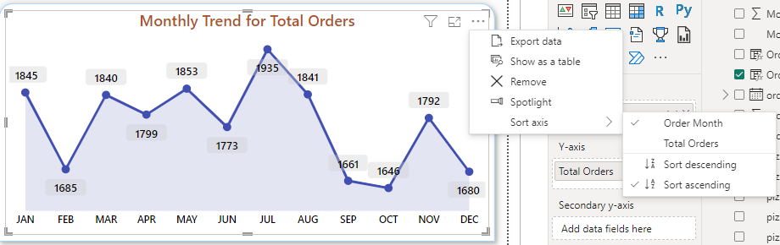

1. Now we will start with our third chart by using donut chart which will show total revenue by pizza category pizza category in legend and total revenue in values.
2. Again, will take donut chart and will put pizza size in legend and total revenue in values.
3. Take funnel chart to show total pizza sold by pizza category and will use conditional formatting in column colours as shown in below picture.

